Health Eligibility Case Management System (HECMS)
Systems Management Guide

Enrollment System Redesign (ESR)

Version 2.1
January 2012

Department of Veterans Affairs
Product Development
Management, Enrollment and Financial Systems (MEFS)
Revision History
Date | Version | Description | Project Manager | Author
11/17/2011 | 2.1 | Imported Tracked Changes from edited copy for ESR 3.6 updates. Figures 2, 9 & 10 updated. VBA Message Bulletins and Mail Groups added. Updated Table 5. Removed HECMS vs. EDB Functionality section. | Glenda Miller | Tom Hamilton
10/26/2011 | 2.0 | Updated document version to correspond with change from 3.5 to 3.6 on cover. Updated Release Dates to December 2011 on cover and footers. Updated ESR 3.5 references to ESR 3.6. Updated Figure 2. | Glenda Miller | Tom Hamilton
9/13/2011 | 1.1 | Updated cover and footer dates to correspond with new National Release date for 3.5 to September 2011. | Jennifer Freese | Tom Hamilton
7/18/2011 | 1.0 | Initiated document version to replace application version on cover. Updated references to ESR 3.5 and dates. | Jennifer Freese | Tom Hamilton
07/07/2011 |  | TW edit for final ORT review. | Jennifer Freese | Tom Hamilton
07/06/2011 |  | Updates for ESR release 3.5 | Jennifer Freese | Sudha Ramani
05/17/2011 |  | Prepared document for upload to VDL. Removed Draft indicators. Added Alt text to all graphics. | Jennifer Freese | Tom Hamilton
02/16/2011 |  | Reviewed/Edited/Formatted  Added missing Table of Figures | Jennifer Freese | Tom Hamilton
02/14/2011 |  | Baselined for version 3.4. Added details for ESR 3.4 – MSDS Web service | Jennifer Freese | Sudha Ramani
09/13/2010 |  | Edits for style and grammar. | Jennifer Freese | Janet Darmanin
09/13/2010 |  | Updated the document to include Enrollment and Eligibility service specific information. | Jennifer Freese | Sudha Ramani
09/13/2010 |  | Baselined for version 3.3. | Jennifer Freese | Janet Darmanin
09/13/2010 |  | Updated 3.0.1 document with changes made on 4/21/2010 to the 3.0 document. Those changes were: Updated 3.0 document with the most current 3.0 information in preparation for uploading to VDL. Added page numbers to footers and changes red fonts to black. | Jennifer Freese | Janet Darmanin
8/11/09 |  | Changed HealtheVet logo cover graphic back to the VA Seal per Brian Morgan. | Sookie Spence | Tom Hamilton
7/7/09 |  | Changed cover graphic from VA Seal to HealtheVet logo. Internal links removed as required by FOIA. Updated cover and footer dates. Updated 3.0 to 3.0.1 where necessary. | Sookie Spence | Tom Hamilton
03/11/09 |  | Provided link to Trouble Shooting Section. | Gerry Lowe | Tavia Leonard
03/11/09 |  | Provided additional comments on HECMS browser information to System Requirement section. | Gerry Lowe | Tavia Leonard
03/11/09 |  | Updated Systems Requirements Section. | Gerry Lowe | Tavia Leonard
03/10/09 |  | Updated Appendix Section. | Gerry Lowe | Tavia Leonard
03/10/09 |  | Provided links to ADR website in Database Section. | Gerry Lowe | Tavia Leonard
03/09/09 |  | Provided links to Security Section. | Gerry Lowe | Tavia Leonard
02/25/09 |  | Updated Introduction section to include references to HEC Legacy System. | Gerry Lowe | Tavia Leonard
02/24/09 |  | Updated Exported Groups and Menus Section. | Gerry Lowe | Tavia Leonard
10/07/08 |  | Added HL7 Inbound and Outbound Messages in Systems Requirements | Gerry Lowe | Tavia Leonard
10/06/08 |  | Updated Trouble Shooting Hardware Base Information. | Gerry Lowe | Tavia Leonard
10/03/08 |  | Added Messaging Flow Process in Systems Requirements. | Gerry Lowe | Tavia Leonard
10/02/08 |  | Added Message Bulletins and Mail Groups in Systems Requirement. | Gerry Lowe | Tavia Leonard
10/01/08 |  | Create Initial draft. | Gerry Lowe | Tavia Leonard

Table of Contents

Orientation 1
How to Use this Manual 1
Commonly Used Terms 1
Introduction 2
Purpose 2
Scope 3
Background 3
Overview 3
Audience 4
Reference Materials 4
System Requirements 5
Server and Workstation Software Dependencies 5
Software Patch Dependencies 5
Messaging Flow Process 6
VistA to HECMS (ESR) 6
HECMS (ESR) to VistA 6
Message Bulletins and Mail Groups 7
HECMS Four Major Components 9
HECMS Software Architecture 9
HECMS Architecture Tiers 10
Presentation Tier 10
Business Tier 11
Data Access Tier 11
HECMS Modules 11
Framework Module 11
Common Module 13
UI Module 13
Messaging Module 13
Workflow Module 14
Workflow Sub-Module 14
Business Rule Engine 14
Workflow Engine 14
E&E Web Service 15
MSDS Web Service Interface 15
Parameters 16
Remote Procedure Calls 17
Web Service Interface 18
Database Information 19
Database Tables and Diagrams 19
HECMS Design Methodology 20
Exported Groups and/or Options and Menus 21
Functionality 21
Security Keys and/or Roles 23
Java Components 24
J2EE Components and Guidelines for HECMS 24
HECMS Component Hierarchy 24
Diagram of HECMS Component Hierarchy 25
HECMS Component View 26
Reporting Tool 26
Set-up and Configurations 27
Configuration Introduction 27
Configuration Control 27
Status Accounting 27
Production Verification 27
Configuration Tools 28
Security Key Controls Assignments 28
Assigning Menus/Options 28
Assigning HealtheVet Desktop Perspective 28
Setting Activation Date 29
Setting Key Assignment 29
Conversion Instructions 29
Troubleshooting 30
Base System Hardware 30
Appendix A: HECMS V3.6 Software Application 32
Appendix B: HECMS Software Application Architecture 33
Appendix C: HECMS Architecture Tiers 34
Appendix D: HECMS System of Systems 35
Appendix E: VA Enrollment & Eligibility System 36
Appendix F: Person Services (PS) & Enrollment (HECMS) 37
Appendix G: Configuration Management Environment 38
Appendix H: ADR Definitions, Acronyms & Abbreviations 39
Appendix I: E&E Service Logical Architecture 41
Appendix J: E&E Service Logical Network Architecture 42
Appendix K: E&E Service Software Components 43
Glossary 44

Tables & Figures
Table 1: Symbols in this Document: 1
Table 2: Commonly Used Terms 1
Table 3: Reference Materials 4
Table 4: Software Patch Dependencies 5
Table 5: HL7 Inbound Messages 6
Table 6: HL7 Outbound Messages 7
Table 7: Message Bulletins & Mail Groups 8
Table 8: System Tools 11
Table 9: Framework Module Services 12
Table 10: Messaging Parameters 16
Table 11: HECMS Design Methodology Components 20
Table 12: Security Keys & Roles 23
Table 13: HECMS Components 26
Table 14: Base System Hardware 31
Table 15: ADR Definitions, Acronyms, & Abbreviations 40
Table 16: Glossary of Terms 44

Figure 1: HECMS Component Hierarchy 25
Figure 2: Screenshot of the HECMS v 3.5 Software Application 32
Figure 3: HECMS Application Architecture Overview 33
Figure 4: HECMS Architecture Tiers 34
Figure 5: HECMS System of Systems 35
Figure 6: VA Enrollment & Eligibility System 36
Figure 7: Person Services (PS) & Enrollment (HECMS) 37
Figure 8: Configuration Management Environment 38
Figure 9: E&E Service Logical Architecture 41
Figure 10: E&E Service Logical Network Architecture 42

Orientation

How to Use this Manual
Several methods are used in this document to highlight different aspects of the material. Three symbols are used throughout this document to alert the reader to pay close attention to specific information.
The table below gives a brief description for each symbol as it appears in the document.
Symbol | Description
 | This symbol is used to inform the reader of general information including references to additional reading material.
 | This symbol is used to caution the reader to take special notice of critical information.
 | This symbol represents specific information that is outlined for the reader.
Table 1: Symbols in this Document:

Commonly Used Terms
The most commonly used terms for this manual are listed below to assist you while reading the 0000.doc.
For more information, see the Glossary found in the back of this manual.
Term | Description
Client | This term refers to a user, workstation (i.e., PC), and the portion of the program that runs on the workstation.
Component | A software object that contains data and codes that can be apparent or undetectable.
GUI | A Graphical User Interface is a means by which users interact with a particular machine, device, computer program or other complex tool (application).
Host | Host is another name used for a server.
Table 2: Commonly Used Terms

Introduction
This document defines and depicts the processes and procedures of the Health Eligibility Case Management System (HECMS) project, a.k.a. Enrollment System Redesign (ESR). The HECMS V3.0 project focused on replacing the HEC Legacy Enrollment System with a more robust, forcible opponent that improves the workflow processes of the end users. HECMS V3.0 was designed to replace the HealtheVet System known as the “HEC Legacy System”. The newly designed architecture provides simplicity, maintenance, functionality, and flexibility for the following agencies:
- Internal Revenue Service (IRS)
- Health Eligibility Center (HEC)
- Social Security Administration (SSA)
These federal agencies have requested the redesign of the “National Enrollment System” in order to support the VHA’s business operations in an effective manner. Currently, the HEC Legacy system is too arduous and challenging to maintain and upgrade. The impacts to the system have resulted in the following consequences:
- Long development cycles in order to produce minimal enhancements.
- Inability to keep pace with legislative and regulatory mandates.
- Engineering limitations that threaten data integrity, performance, and user acceptance.
Creating and producing a large-scale enterprise application involves a collective amount of processes and technologies for building an adaptable, plausible, and resilient architecture. The primary purpose for developing a comprehensive system is to deliver an application designed to calculate and manage eligibility and enrollment decisions. Another factor includes creating workflow management solutions while providing healthcare benefit services to VHA beneficiaries.
The HECMS system communicates with other major VHA enterprise systems through using the following methods:
- Asynchronous messaging protocol
- Synchronous messaging protocol
The users for this system interact through a web-based interface that resides on the VHA network infrastructure.

Purpose
The purpose of this document is to provide a uniform approach that describes the processes, procedures, delivery, and maintenance of HECMS from a high-level perspective. This document outlines the different components of the HECMS activities that involve tracking, auditing, and verification management. The information contained in this document applies to the development and design of the system.
The primary objective for developing HECMS is to enhance the operational efficiencies of the HEC who are responsible for processing and managing Veterans’ enrollment health benefits.

Scope
The information outlined in this document applies to activities conducted within the HECMS environment. The scope of this document is tailored to provide technical support, details, and strategies for managing and defining the HECMS project.
The system is comprised of use cases that are re-engineered to create a robust and dependable architectural system that can withstand the high demands that are placed on it.

Background
The Veterans Health Administration (VHA) and the Department of Veterans Affairs (VA) administers to the largest integrated health care system in the nation. In accordance to the Veterans Health Care Eligibility Reform Act of 1996, Public Law 104-262 requires that VHA implement a priority based enrollment system. Since 1996, the VA enrollment process has increased significantly and is expected to continue growing.
All income and eligibility information is collected and verified at the HEC facility. This information determines healthcare enrollment and medical benefits for a Veteran. A significant portion of the enrollment process involves enhancing and maintaining the Enrollment System (ES).
ES is a web-based case management system that allows the user to track and manage the Veterans’ healthcare enrollment processes. The ES receives enrollment applications with updated information describing Veterans’ demographics, financial, eligibility, and enrollment information from the local Department of Veterans Affairs Medical Center (VAMC) sites.

Overview
HECMS consists of redesigning the existing HEC Legacy system through enhancing the workflow and communications methods obtained from different sites. The scope of this project epitomizes the functionality for enrollment, eligibility, and income verification matching required by Veterans in order to attain the appropriate healthcare benefits from VHA. Now that the system is completely in place, it will enhance the operational efficiencies for the following agencies:
- HEC
- VAMC
- Austin Information Technology Center (AITC)
The system application will provide users with appropriate access to Veterans’ data and knowledge base information, supporting both business and technical data while ensuring superior service to all Veterans.
To learn more about the latest HECMS application version, visit the ESR TSPR website. Additional documentation may be found on the Enrollment SharePoint (VA internal website) as well as the VistA Documentation Library (VA external) website.

Audience
The primary audience recommended for this document consists of the following groups:
- Project Management
- Architects
- Modelers/Designer/Developers/Business Analysts
- Configuration Managers
- QA Managers
A secondary audience includes recipients from various deliverable processes and procedures executed from the configuration environment. The secondary audience encompasses the following groups:
- Team Leads
- SQA Analysts

Reference Materials
Name | Description
ESR Project Overview | Provides a high-level overview of the functionality and enhancements of the HECMS V3.0 System.
Enrollment System Redesign Vision V1.0 | Provides details of the HEC – HECMS V3.0 capabilities described in Business Use Case specifications.
ESR Configuration Management Plan | Describes the processes and procedures of the HECMS V3.0 project lifecycle.
ESR Design Database Design Concepts | Describes the HECMS methodologies and implementation process.
ESR Enrollment Service Design Document | Describes the capabilities provided by Enrollment and Eligibility (E&E) service.
ESR Use Cases, Interface Control Document, Supplemental Specification | Constitutes the current requirements deliveries to the Enrollment System.
Table 3: Reference Materials
To learn more about HECMS V3.0 information listed above, visit the ESR 3.0 TSPR website. Additional documentation may be found on the VistA Documentation Library (VA external) website.

System Requirements
This segment describes the artifacts of the System Requirements Management process that controls and supports the evolution of HECMS.
System Requirements expounds upon the condition of interdependent elements that interact, correlate, and derive from complex groups based upon users’ needs and specifications. The HECMS process employs a combination of document and relational database techniques that store and manage requirements. The requirements are warehoused in an Oracle database and the contents are managed through an IBM tracking and monitoring tool called RequisitePro. This tool provides support and traceability for HECMS hierarchy.
HECMS is an enterprise-wide system used to manage Veterans’ enrollment processes through authorizing HEC users to track and manage healthcare benefits. This application replaces an aging augmented manual system with a user friendly accelerated productive one.
See Appendix F: Person Services (PS) & Enrollment (HECMS)

Server and Workstation Software Dependencies
The following software dependences and version requirements do not apply to the HECMS System: J2EE, BEA, WebLogic, and VistALink
HECMS uses the standard VA approved configurations which consist of the following: Microsoft Internet Explorer (IE6 or higher), SP3, Popup-Blocker Enabled, No Proxy Settings.
The HECMS system does not require any special browser configuration. This system will allow you to use Firefox; however, the current standard VA minimum approved application is IE6.

Software Patch Dependencies
The following VistA software patches are required prior to installing HECMS.
Host File Name | Patch One | Patch Two | Patch Three
DG hostfile DG_53_P688.KID | DG_5_3_P688 | IVM_2_P115 | EAS_1_P70
SD hostfile SD_53_P441.KID | SD_5_3P441 | DG_5_3_P664 | PX_1_P168
Radiology | RA_5_P70
Laboratory | LR_5_P352
HEC Legacy Patch | IVMB_2_P886
Table 4: Software Patch Dependencies

Messaging Flow Process
The Vitria Interface Engine (VIE) requires that all message types are restricted to 100 records per batch message. This functionality aids in restricting large volume batches from occurring while allowing the system to take advantage of the multiple queues that are available.

VistA to HECMS (ESR)
VistA to ESR solicited and unsolicited HL7 messages will be created and transmitted from VistA to HECMS (ESR) via port and IP address. Vitria will automatically engage in cursory messaging structure syntax format checking before sending it to ESR. ESR then validates the data and if the data is determined to be clean, the completed records will be committed and an “Acknowledgement (ACK)” message is prepared for transmission back to the VISTA site. However, if a “Negative Acknowledgement (NAK)” message is received; it is then prepared for transmission back to the VISTA site.
Note: When transmitting messages from VistA to ESR, the Receiving Application must be “ESR” and the Receiving Facility in the header segment must be “200ESR”.

HECMS (ESR) to VistA
ESR to VistA solicited and unsolicited HL7 messages will be created and sent. Vitria will send the message to the appropriate VISTA site. Existing receiver software at the VISTA site will process the data. The general behavior for outbound messages is ESR will send double-quotes ("") to represent deleted or null data. If ESR does not have any data to populate the segment, it will not be sent through an outbound message.
HECMS receives the following HL7 Inbound Messages
IVM ORU-Z05 | Demographic (Change of Address) Data – MVR
ORU-Z07 | Full Registration
ORF-Z07 | Full Registration Reply
ORU-Z11 | Eligibility / Enrollment Data from MVR
ORF-Z11 | Eligibility / Enrollment Data from MVR Query Response
ORU-Z12 | Death Data (currently disabled)
ORU-Z13 | Lazarus Death (Death Data sent in Error) (currently disabled)
MFK- ZEG | Master File Acknowledgement
QRY-Z10 | Financial Query
QRY-Z11 | Eligibility / Enrollment Query
Table 5: HL7 Inbound Messages

HECMS transmits the following HL7 Outbound Messages
ORU-Z04 | IVM Insurance Policy Data
ORU-Z05 | Demographic (Change of Address) Data
ORU-Z10 | Income Test Data
ORF-Z10 | Financial (Income Test Data) Query Reply
ORU-Z11 | Eligibility / Enrollment Data
ORF-Z11 | Eligibility / Enrollment Query Reply
MFN- ZEG | Master File Notification
QRY-Z07 | Full Registration Query
QRY-Z11 | Eligibility / Enrollment Query to MVR
Table 6: HL7 Outbound Messages
All messages are queued internally as part of asynchronous handling of HL7 messaging. The messages are transmitted in real time.
HL7 message processing within the HECMS system does not have to wait for background jobs.

Message Bulletins and Mail Groups
1 | Message= HL7 - Z07 from site  Bulletin=HEC Notification of POW Discrepancy  Mail Group= G.DGEN Eligibility Alert @(site).med.va.gov
2 | Message= HL7 - Z07 from site  Bulletin=HEC Notification of Need for Site to Verify Veteran  Mail Group=G.DGEN Eligibility Alert @(site).med.va.gov
3 | Message= ORU/ORF Z07  Bulletin=Inconsistent Conflict Data from Site.  Mail Group=Send to site that sent the inconsistent data.  The mail-group is- g.DGEN ELIGIBILITY ALERT (SITE).MED.VA.GOV
4 | Message= ORU/ORF Z07  Bulletin=Inconsistent Conflict Data from Site  Mail Group=Send to site that sent the inconsistent data.  The mail group is - g.DGEN ELIGIBILITY ALERT (SITE).MED.VA.GOV
5 | Message= ORU/ORF Z07  Bulletin=HEC Notification of Need for Site to Send Ineligible Information  Mail Group=G.DGEN Eligibility Alert @(site).med.va.gov
6 | Message= ORU/ORF Z07 (TBL 235.2)  Bulletin=HEC Notification of Need for Site to Verify Veteran  Mail Group=G.DGEN Eligibility Alert @(site).med.va.gov
7 | Message= ORU Z07  Bulletin=HEC Notification of Need for Site to Verify DOD Deletion.  Mail Group=G.DGEN Eligibility Alert @(site).med.va.gov
8 | Message= ORF~Z11 from VBA  Bulletin=Solicited Z11 did not match on a Person  Mail Group=VHA CIO HECAlert Mailgroup - HECAlert@med.va.gov
9 | Message= Receive Query Z11  Bulletin=Eligibility Not Verified, Call HEC  Mail Group=Send to the site that sent the query - G.DGEN Eligibility Alert (site).med.va.gov
10 |  | Message= ORU/ORF~Z11 from VBA or manual update via UI  Bulletin= HEC Notification of NSC to NSC, VA Pension  Mail Group= G.DGEN Eligibility Alert @(site).med.va.gov
11 |  | Message= ORU/ORF~Z11 from VBA or manual update via UI  Bulletin= HEC Notification of SC and NSC, VA Pension  Mail Group= G.DGEN Eligibility Alert @(site).med.va.gov
12 |  | Message= ORU/ORF~Z11 from VBA or manual update via UI  Bulletin= HEC Notification of NSC, VA Pension and HB  Mail Group= G.DGEN Eligibility Alert @(site).med.va.gov
13 |  | Message= ORU/ORF~Z11 from VBA or manual update via UI  Bulletin= HEC Notification of NSC, VA Pension and A&A  Mail Group= G.DGEN Eligibility Alert @(site).med.va.gov
14 |  | Message= ORU/ORF~Z11 from VBA or manual update via UI  Bulletin= HEC Notification of Terminated VA Pension SC  Mail Group= G.DGEN Eligibility Alert @(site).med.va.gov
15 |  | Message= ORU/ORF~Z11 from VBA or manual update via UI  Bulletin= HEC Notification of Terminated VA Pension SC  Mail Group= G.DGEN Eligibility Alert @(site).med.va.gov
Table 7: Message Bulletins & Mail Groups
To learn more about HL7 transmissions messaging process, review the Interface Control Document (ICD) on the HECMS Customer SharePoint website.

HECMS Four Major Components
A set of functionalities supported by HECMS are assembled into four major subcategories. The subcategories are grouped into a functional domain that warehouses four predominant components. This infrastructure has allowed the technical and business stakeholders the ability to recognize the necessary IT components that encompass HECMS core structure.
Due to the nature of the data required for enrollment services, other internal and external services rely upon the support from HECMS. The two supporting services include the following departments:
- Person Service (PS) – represents a set of APIs for person demographics and identity traits for users and veterans that are residing within the VHA environment. PS includes the following data elements:
  - Full Name (first, middle, last)
  - Date of birth
  - Gender
  - VPID (The unique identifier for each Veteran)
  - SSN
- Name Directive Service (NDS) – offers a set of look-up APIs to other internal services.
This was eliminated in ESR 3.5. The PSIM EJB endpoints are hard coded in ESR configuration files.
The correlation between HECMS and PS is a bidirectional one. All requests for address updates and email changes are initiated through PS to HECMS. However, there are specific business processes that include person demographics and SSN updates changes that are requested through HECMS to PS. Another significant focal point to address is the different API calls HECMS has included within the PS libraries. The PS libraries store JAR (Java ARchive) files commonly known as Enterprise Java Beans (EJB), which are distinct modules that can be modified only through a planned release schedule.
See Appendix F: Person Services (PS) & Enrollment (HECMS)

HECMS Software Architecture
The HECMS architecture represents a dynamic service-supported system that incorporates an event-driven broadcast paradigm. The architecture has an advancing assiduous runtime environment, where loose couplings between service providers and service consumer components engage in a robust and pliable interaction. This method allows the communication model to respond proportionately to real-time and stimuli changes compared to conventional request/reply mechanisms.
Listed below are the components that represent the HECMS architecture:
- Business Service Layer – a set of modular elements that are responsible for controlling the expert system and workflow functionalities. These services are accessed through external clients (e.g. future web services or messaging components). Only two different sets of consumers (User Interface and Messaging) have direct access to these services.
- Event Layer – represents the method of communication between the service layer (producer) and the following external and internal interfaces: UI, Messaging, or Internal Services (consumer).
- Presentation Layer – this layer is implemented through Struts. The tool consists of a based solution that provides pagination, security, and caching for the HECMS system.
- Messaging Layer – a messaging component (asynchronous) that is designed utilizing Java Message Driven Beans.
- Data Access Layer – this layer employs the Hibernate 3.0 object relational mapping tool that is interwoven within the “Spring” framework.
- Web Services Layer– this layer exposes web services that can be consumed by the other systems or applications within VA. E&E service is the first web service provided by HECMS that facilitates other systems’ requests for E&E data stored within ADR.
The HECMS system is designed with the objective of minimizing and concealing complexities from the application developers. The concept of reusing versus reinventing was a crucial driving force behind redesigning the entire ES architecture. The HECMS architecture is derived from several open source projects in the Java community, along with many integrated customized shell tools.
This document provides information on the Java components that are used in the HECMS Component Hierarchy. For more information on the subject matter, review the Java Components section of this document.
See Appendix B: HECMS Software Application Architecture

HECMS Architecture Tiers
HECMS architecture environment originates from various open source projects driven by the Java society. The architecture environment is composed of the following three tiers:
- Presentation Tier
- Business Tier
- Access Tier

Presentation Tier
The Presentation Tier framework is provided through “Struts”, a web-based solution tool that allows the architecture the ability to concentrate on creating elements that plug into the framework. The usage of Struts provides a standard way of implementing specific system functionality, including mapping users’ actions as offered through the Business Tier component.

Business Tier
The primary functionality of the Business Tier is to control the workflow processes and services offered through the application server. The workflow processes and services include business use cases, web services, and delivery service messaging, better known as the interface engine.

Data Access Tier
The Data Access Tier consists of an object relational tool used in mapping the domain that resides on the “Oracle 10 DBMS” package. Information travels directly between objects and the database while maintaining separate classes from each other. The business aspects are located in distinct classes that concentrate on data representation and domain logic. Caching occurs at this level, which reduces the number of network calls and application latency and results in improved response time for the application.
See Appendix C: HECMS Architecture Tiers

HECMS Modules
The HECMS application consists of four major modules. Each of these modules correlates with a set of services that are assiduous through other internal or external clients. The set of services consists of the following members:
- Framework Module
- Common Module
- Messaging Module
- Workflow Module (EDB)

Framework Module
The Framework Module administers to a powerful toolbox used within the development environment. This module aids in many different areas of the application development by providing crucial fundamental design patterns and formation to the project. In addition, it supports the necessary hooks required to integrate with third party libraries, which includes the following tools:
Systems Tools
Hibernate | Struts | ILOG | Spring | Log4j
Table 8: System Tools
One of the most conventional design patterns used in the framework layer is the template pattern. The template pattern consists of a flexible and stable design pattern used to implement the variant behavior relationship of the HECMS environment. The framework module controls and monitors the behavior patterns of the HECMS system through a series of patterns. In addition to the template pattern, the framework “Services” is another enhancement.
Services that are provided within the framework include the following set of functionalities.
Template | Definition
UI Service | Provides a set of hooks required to integrate with the Struts and Spring framework.
Business Service | Contains an abstract service broker class that is extended by external components to invoke services from the UI and Messaging layers.
Trigger Service | Provides components and interfaces that are useful when various subsystems need to trigger events to each other. This event-driven process can be either synchronous or asynchronous, depending on the implementation.
Rule Service | Defines the integration point between the J2EE environment and the ILOG JRule execution manager. One of the key features is the ability to pass POJO components from the service layer to the JRule execution manager.
Security Service | Includes all classes of authentication and authorization management. The package is based on JAAS standards using a Pluggable Authentication Module (PAM) framework. This service allows HECMS to remain independent from underlying authentication technology.
Persistence Service | Uses a Hibernate session manager combined with Spring DAO support to perform Read and Write capabilities and is located on the Data Layer.
Pagination Service | Provides support between the Spring and ValueList toolkit. The ValueList toolkit comes with JSP tags that handle the rendering of the HTML paginated data and UI classes.
Model Service | Defines a list of behaviors that are required for the management of Data transfer layer used to compare with the creation information (who and when).
HL7 Builder Service | Allows the user to build message segments or message objects from HL7 raw data. In addition, it gives the user the ability to transform an object representation into a HL7 message.
Report Service | An open source Java reporting tool that reports dynamic or scheduled templates for the HECMS environment.
Table 9: Framework Module Services

Common Module
The engineering of the Common Module depicts the classic J2EE business logic layer that stores the core functionality of the HECMS business components. These components serve as a wrapper that limits what the front-end process receives from the back end process. The wrapper serves as a boundary that safeguards the system.
The Common Module contains the core functionality of the HECMS business components through Plain Old Java objects (POJO). The common module utilizes a separate JAR file that is package inside two EAR files (Messaging and UI). Separating the core elements provides the architecture the flexibility required to deploy and reuse components across both Messaging and UI projects.
The Common Module warehouses the following elements:
- Service Layer
- Business Process
- Data Transfer Objects
- Rules Services
- Data Access Components
The following Services are only available through the Common Module:
- Enrollment Service – concentrates upon the enrollment and eligibility calculation for a new or existing Veteran.
- Person Service – processes data (demographics, military service, financial) for new and existing Veterans.

UI Module
The UI Module represents the Presentation Tier of the HECMS architecture. The foundation is built upon a Struts infrastructure that adds many new enhancements to the HECMS environment. UI displays a paging mode that allows the user the ability to concentrate on specific items versus a large list. The combined elements of the UI module pagination capabilities, the Business Tier attributes, and the security attributes provide for a seamless integration.
Security is another feature that the UI module provides, which includes an encryption mechanism that hides form fields and URL links on the Java Server Pages.

Messaging Module
The Messaging Module is a set of services that provides support for passing messages between distributed applications. This method is accomplished through encapsulating messages that are sent between a sender and a receiver from a reliable (asynchronous) independent platform that supports communication with other internal VHA services. The entire process is achieved through Java Messaging Service protocols.

Workflow Module
HECMS core functionalities are processed and managed through the Workflow Module. This module controls and manages groups of use case requirements and specific events that manifest daily throughout the project.
This module offers the following sets of capabilities:
- Inbound Services – allows the user the capability to create, search, and assign specific cases. This service is employed through the UI module once a HEC user performs a certain set of case management functionality.
- Outbound Requests – represents the external set of requests that are made through the workflow module depending upon the use case scenario. The triggering events are managed and maintained through the outbound request sub module.

Workflow Sub-Module
The following elements are controlled and processed through the outbound request sub module located in the Workflow Module:
- Workflow Cases – encapsulates data through the BOM classes of the workflow management engine.
- Workflow Events – occurs whenever a new EE calculation takes place. These events are initiated only when a HL7 message is processed.

Business Rule Engine
The Business Rule Engine substructure is a robust and agile development tool used for testing and deploying the processes that manage Veterans’ enrollment and eligibility benefits. The primary purpose for developing the Business Rule Engine is to determine Veterans’ level of eligibility. This process is accomplished by applying and executing a number of business rules and computation tasks that undergo frequent updates and revisions. This mechanism abstracts and scales all business rules.

Workflow Engine
The Workflow Engine is aimed at arranging “out-of the box” case management from methods used for monitoring capabilities. It provides the case workers at the HEC with the quintessential tools that are required for defining, examining, and modeling business processes that directly meet their specifications. The Workflow Engine can identify bottlenecks accurately through auditing the systems performance.
A “third party” rule engine is also used to administer to the application logic. The “ILOG JRule,’ engine manages the execution of business rules and logics that are associated with the HECMS system. The ILOG engine separates rules into a managed execution formation that allows testing and controlling the application components more effectively.

E&E Web Service
In order to provide appropriate services to Veterans, many divisions within the VA need access to the authoritative Eligibility and Enrollment information that the Health Eligibility Center maintains. The E&E web service provides this information, maintained in ADR database, to authorized consumers, and customizes the information based on their roles and their needs.

MSDS Web Service Interface
Military service information is required by the VHA Health Eligibility Center (HEC) to support the processing of Veteran eligibility and enrollment priority for VA Healthcare. This newly developed inter-connection between VHA Enrollment System Redesign (ESR), VA/DoD Information Repository (VADIR), and the VBA Beneficiary Identity Record Locator System (BIRLS) enables VHA to streamline enrollment of veterans for VA Healthcare through automation of the ESR system to include enhanced access to a Veteran's military history information. Through this interface, ESR enables HEC users to view authoritative military service information when verifying eligibility and enrollment priority for VA Healthcare.

Parameters
The table listed below depicts the following Parameters captured from HECMS Messaging.
File Name | Global
AA | Represents the count for application acknowledgements.
AA% | AA count divided by trans_log count.
App Config | Applies to the configuration formatting of the application server:  - The number of machines  - The number of processes for each machine
Batch ID | Used for each test to track a batch file.
Batch Size | Represents the number of messages per batch file.
CPU | Sustained CPU usage for each application server.
DNIM | Indicates the size of the data that is not in motion prior to testing.
Msg Count | The volume of the input messages.
Msg_In_Dir | Represents the count of messages in Message_In_Dir on the applications server.
Msg_Out_Dir | Represents the count of messages in Message_Out_Dir on the applications server.
New/Old | The number of messages from a new Veteran or existing Veteran.
Outack_q | Represents the count in to/out of the acknowledgment queue.
Outq_rsltq | Represents the count in to/out of the query_ result queue.
Rate | The message processing rate in messages per second.
RunID | Each ID is mapped back to a test case or test sub-case.
Start/End/Time | Tracks the first and last logged transactions
TTFB (Time to First Byte) | The number of milliseconds that has passed before the first byte response was received.
TTLB (Time to Last Byte) | The number of milliseconds that has passed before the last byte response was received.
Trans% | Transaction log count divided by message count.
Trans_Log | Used to calculate the rate of a message transaction.
Trans_log2 | Count of secondary processing due to processing of QRY-Z10/11 messages.
Vet% | Veteran count divided by message count.
Table 10: Messaging Parameters

Remote Procedure Calls
HECMS does not expose Remote Procedure Calls (RPC) via the CAIP (RemoteEJB) interface.

Web Service Interface
- For the details on E&E web service interface, please review the Interface Control Document (ICD) on the HECMS Customer SharePoint website.
- For the details on MSDS web service interface, please review the Interface Control Document (ICD) on the HECMS Customer SharePoint website.

Database Information
This section describes the many benefits that HECMS offers along with the major advantages it has over the aging EDB system.
The Administrative Data Repository (ADR) is the official database used by the HECMS system. ADR is designed to support the storage of administrative data for the VHA Legacy HEC system. It provides the capability to store data received from VistA files.
ADR supports administrative data elements relative to multiple categories of a “Person Entity”. Initially, it was built to focus upon the computing needs of VHA. ADR is positioned to provide identity management and demographics support for all IT systems within the Department of Veterans Affairs.
As the authoritative data store for cross cutting administrative person data, ADR establishes and manages data as a corporate asset. ADR is centralized and has the ability to distribute administrative data across geographically.
See Appendix H: ADR Definitions, Acronyms & Abbreviations to view ADR definitions and acronyms

Database Tables and Diagrams
ADR tables are categorized and based on functional components. All Identity Management tables and Demographics data resides in a separate schema called PSIM. All other tables in the ADR schema support Enrollment and Eligibility data. ADR connects to SDS for reference data and leverages common services in order to host applications.
Functional Components consist of the following:
- Data Sources:
  - PSIM Data – migrates from the Master Patient Index (MPI)
  - PSD Data – migrates Person Service Demographics tables
  - ESR Data –migrates from Health Eligibility Center (HEC) files
- Table Counts (approximately):
  - 50 Identity Management tables
  - 20 Demographics tables
  - 70 Enrollment tables
- Data Statistics (approximately):
  - 30 million Person records
  - 60 million Enrollment determination records
To learn about all of ADR tables, diagrams, and models, review the ADR Phase II TSPR site.

HECMS Design Methodology
HECMS design principals are based on a large-scale enterprise solution that is designed to manage eligibility, enrollment, and workflow decisions by providing healthcare benefits and services to all VHA beneficiaries.
The HECMS design methodology encompasses the following components:
Name | Definition
HECMS Application | The application is composed of two major subsystems:  - Case Management  - Expert Subsystem
 | ADR is a data repository that warehouses all HECMS data elements and services.
HECMS System | The system is designed with software layers and service based principals that are segmented under two major components:  - Enterprise Framework  - Application Component
Table 11: HECMS Design Methodology Components

Exported Groups and/or Options and Menus
The Enrollment VistA Changes Release 2 (EVC R2) project supported technology and business changes that occur during the implementation of the HECMS project. The EVC project was broken up into three phases: EVC - Early Release; EVC - Release 1, and EVC - Release 2. The EVC R2 project introduced additional functionality in preparation for HECMS to become the system of record. The following VistA packages were modified in order to fulfill the following business requirements/groups:
- Registration
- Enrollment
- Income Verification
- Scheduling
- Patient Care
- Radiology
- Laboratory
All changes are included in a combination of host files and individual patches. The names of the installed patches and host files are listed below:
- Location for all host files:
- ANONYMOUS.PUB on the Albany server
- Enrollment Hostfile DG_53_P688.KID (Patches included in the host file)
- DG*5.3*688
- EAS*1.0*70
- IVM*2.0*115
- Scheduling Hostfile SD_53_P411.KID (Patches included in the host file)
- SD*5.3*441
- PX*1*168
- DG*5.3*664

Functionality
The following enhancements were provided with Release 2 (R2):
- New field to capture and share Permanent and Totally (P&T) Disabled effective date information.
- Upload POW captivity dates and location information as sent from ESR.
- Implement South West Asia changes.
- Provide the ability to process SHAD/Project 112 Exposure.
- Share the effective date(s) of inactivation for spouse and/or dependent.
- Add consistency checks for date of marriage and dependent effective date.
- Implement SSN verification changes.
- Enhance address sharing functionality.
- Share Non-Veteran data (with the exception of Employee only data).
- Implement new ‘Not Applicable’ enrollment status.
- Align the value for 'Patient Type' between VistA and HEC.
- Implement 10-10EZ changes.
- Allow collection of funeral and burial expenses for Veterans who do not have a spouse or dependents.

Security Keys and/or Roles
Roles
Local Administrator | ISO | Report Viewer - DQM
System Administrator | IRM | Report Viewer - LAS
EE LAS | Report Manager- Everything | Report Viewer - PSC
EE Supervisor | Report Manager - DQM | Report Viewer - SSN
DQ Supervisor | Report Manager - LAS | Report Viewer - NON-HEC Limited
Director | Report Manager - PSC | Undeliverable Mail Manager
EE Program Clerk | Report Viewer - Everything | EGT Manager
VistA Clerk | Report Viewer - Non-HEC | IV LAS
Call Center Clerk | Report Viewer - HEC
HEC Administrator | E&E Service Request Management  E&E Service User Management
Table 12: Security Keys & Roles
Federal policies require that all IT positions are evaluated and that a sensitivity level is assigned to the position description. A background investigation is required for all VHA employees filling sensitive positions. VHA personnel and non-VHA personnel, including contractors, shall have personnel security clearances commensurate with the highest level of information processed by the system.
User access is restricted to the minimum necessary to perform the job. Each HECMS user is assigned privileges that allows or restricts updating, deleting, and/or inserting records in the database. In addition, HECMS uses application-level security controls to limit access to various system functions to only authorized users.
To learn more about the roles and the levels of access assigned to users, review the VHA Standard Data Service (SDS) tables.

Java Components

J2EE Components and Guidelines for HECMS
HECMS consists of a scalable, modular architecture that is built upon a J2EE structure. The technical specifications for HealtheVet standards apply to the enterprise level application, which enforces the rules that all components must comply with the HealtheVet guidelines.
The J2EE components consist of XML files that control the behavior of the framework services. This is relevant at all levels of the architecture that affect business objects and metadata used to define attributes. The workflow or transaction level adopts the XML file needed in order to process the flow of complicated tasks.
The HECMS design patterns are used in solving recurring problems that occur within the software development stage. The HECMS architectural uses a number of different design patterns that includes Template, Visitor, and many other factory based designs.
The standards and guidelines for HECMS are the primary drivers behind selecting the appropriate set of tools for the overall design and development of the architecture.

HECMS Component Hierarchy
The HECMS Component Hierarchy consists of software layers, components, design subsystems, and design services that are used to organize data. The layers are constructed to provide support for base functionality for other layers. The components represent business processes that are unique solely to the HECMS architecture by separating system levels. This method reduces the complexity of the system for the development team and minimizes the cost and risk that are associated with implementing and maintaining the system.

Diagram of HECMS Component Hierarchy
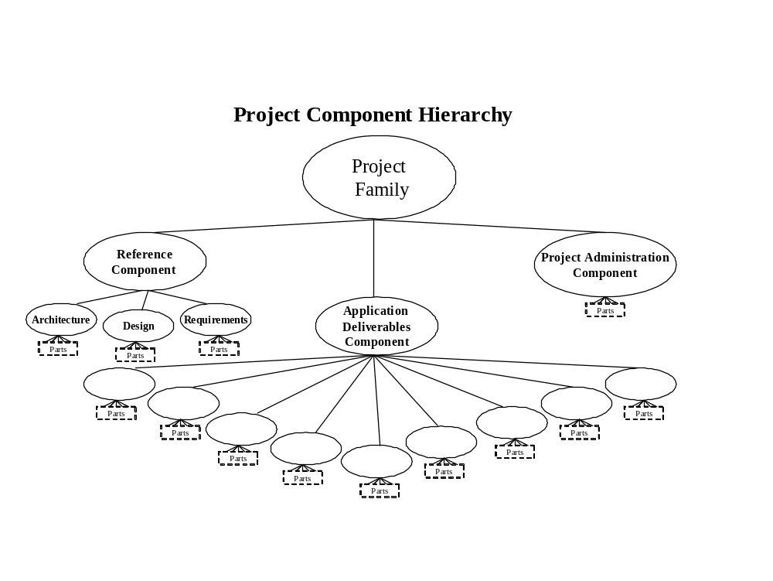
Figure 1: HECMS Component Hierarchy

HECMS Component View
The HECMS Component View describes the tools used to connect and deliver the physical system at the highest level by redesigning the system into classes.
The sub-level packages used in the J2EE development are imported into the Rose model structure standards where component specifications are maintained during modeling activities described in the JavaDoc utility.
The table below illustrates the following components found in a high-level package.
HECMS Components
com | gov | ilog
implementation model | Java | javax
junit | Net | oracle
org | sun | WebLogic
main
Table 13: HECMS Components

Reporting Tool
The reporting tool used for HECMS is known as Jasper Reports. This tool is designed by Java and was selected primarily for its effectiveness in governing functional capabilities suitable for supporting solutions. The tool delivers the following files: PDF, HTML, XLS, and CSV.
Jasper Reports was written entirely in the Java language and is integrated in the HECMS architecture to include both the dynamic and schedule reporting. The dynamic and schedule reports are designed for the users to have the ability to control the template, data elements, and output. All schedule reports are automatically generated through the system.

Set-up and Configurations

Configuration Introduction
This section identifies processes and procedures involved in the complexity of HECMS interfacing with other VA and external applications. This document will provide knowledge on the following environments:
- Production Verification
- Status Accounting
- Project Auditing
- Interface Management
- Configuration Control
HECMS was using the Naming Directory Service (NDS) for its CAIP touch points with other HealtheVet systems. NDS was configured on a separate physical server and contains the physical end-points of all remote services. For example, HECMS was using NDS to communicate to PSIM and vice versa. Since NDS was maintained actively by any group, in ESR 3.5, the NDS interface was eliminated.
Note: This is not applicable for ESR 3.5 and later.

Configuration Control
Configuration Control manages all software, hardware, operating systems, documentation, and environmental configurations. The primary function of the configuration control process is to maintain a conventional and reliable environment for the creation and implementation of a product. All configurable items that initiate modifications within the design and development process are monitored and regulated through Configuration Control.

Status Accounting
Status accounting configuration targets all tracking, reporting, and recording of data required to operate and control the project. This includes change request that identify the foundation resource usage of the overall systems condition and present state.

Production Verification
The HECMS testing process includes performing an informal test readiness that occurs before the actual system testing. All deficiencies that impact internal issues are reported and addressed through the HECMS staff. The data is reviewed and resolution is determined for all front-end and back-end defects.

Configuration Tools
The Rational Suite contains ClearCase and ClearQuest tools, which are the preferred choice for managing problems, tracking, and notification processing within the CM Environment.
The Configuration Management diagram depicts the various tools selected for developing the HECMS project:
- CR Data Base
- Planning & Reporting
- Access Control
- CM Administrative
- Build
See Appendix G: Configuration Management Environment

Security Key Controls Assignments
Listed below are the minimum-security controls that were put in place prior to authorizing HECMS for processing:
- Technical and/or Security evaluation completed.
- RA conducted.
- Rules of behavior established and signed by users.
- Contingency plan developed and tested.
- Security plan developed, updated, and reviewed.
- Assurance that the system meets all applicable federal laws, regulations, policies, guidelines, and standards.
- In-place adequate and appropriate planned security safeguards.

Assigning Menus/Options
Not applicable.

Assigning HealtheVet Desktop Perspective
HECMS is a web-based system, not an application.

Setting Activation Date
Not applicable

Setting Key Assignment
Not applicable

Conversion Instructions
Not applicable
To learn more about HECMS Configuration information, see the ESR_3_0_Configuration.pdf document in the ESR 3.0 TSPR Project Notebook.

Troubleshooting

Base System Hardware
All hardware is located at the Austin Information Technology Center (AITC) Austin, Texas.
The following minimum standard equipment is required before troubleshooting the system. For the actual system resources for each release, contact the AITC in Austin, TX.
System Resources
Resource | Quantity | Name and Type
Java Server | 3 | Dell Power Edge 2850  Base Unit: PowerEdge 2850, 3.6 GHZ/2M Cache Xeon, 800MKz Front side Bus  Processor: Dual Processor for 800FSB, PowerEdge 2850  Memory: 8GB DDR2, 400MHz  Operating System: Windows 2003 Enterprise Edition, 25 Client Access Licenses English (420-3895); Linux RedHat Advanced Server 4.0 Update 2
Web Server | 3 (clustered) | Dell Power Edge 2850  Base Unit: PowerEdge 2850, 3.6 GHZ/2M Cache Xeon, 800MKz Front side Bus  Processor: Dual Processor for 800FSB, PowerEdge 2850  Memory: 8GB DDR2, 400MHz  Operating System: Windows 2003 Enterprise Edition, 25 Client Access Licenses English (420-3895); Linux RedHat Advanced Server 4.0 Update 2
Database/Data Server | 2 | HP 9000 Superdome 32-way server  Base Unit: HP Superdome EDB has a hard partition on each server consisting of 8 CPUs  Processor: PA8700+ 875MHz CPU  Memory(16GB): 512Mb DIMM  Hard Drive: 36GB  DVD Drive: DVD ROM Device for HP Server Superdome systems  NIC: PCI 1000Base-T Fibre Channel Adapter; PCI 10/100Base-T LAN Adapter  Operating System: HP-UX Enterprise OE Server Media - HP-UX 11i Version 1
Table 14: Base System Hardware
To learn more on troubleshooting information, see the ESR Troubleshooting Guide.pdf document in the ESR 3.0 TSPR Project Notebook. This is a living document and will be updated periodically.
- HECMS V3.6 Software Application
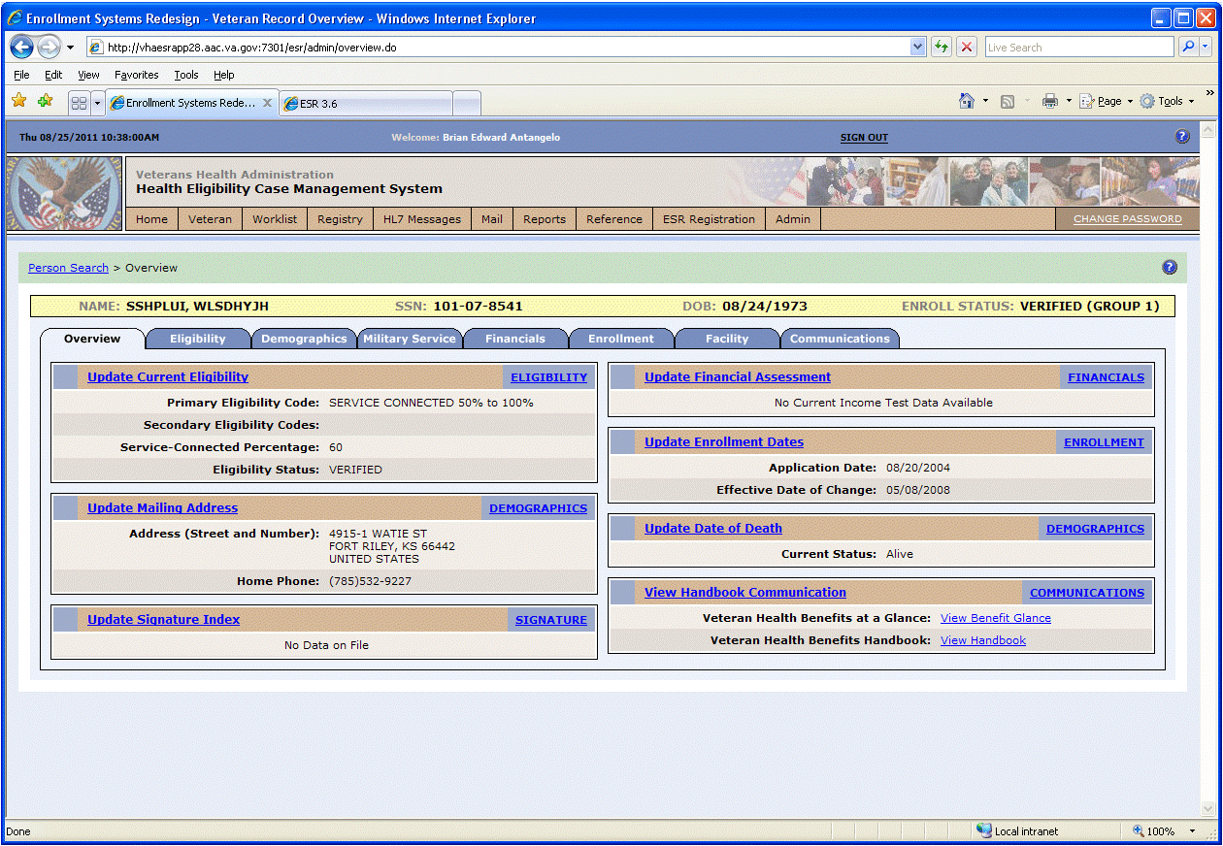
Figure 2: Screenshot of the HECMS v 3.6 Software Application
- HECMS Software Application Architecture
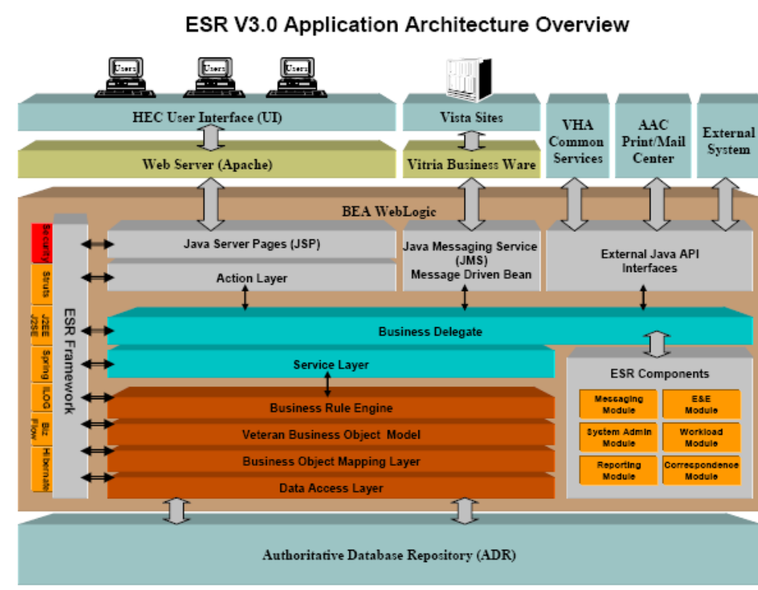
Figure 3: HECMS Application Architecture Overview
- HECMS Architecture Tiers
Presentation Tier Business Logic Tier Data Tier
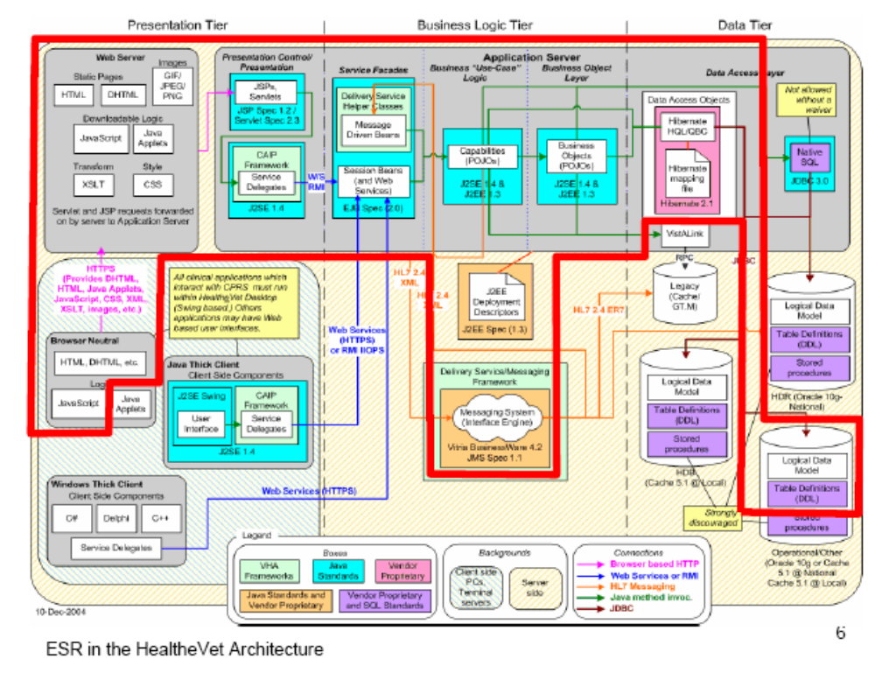
Figure 4: HECMS Architecture Tiers
- HECMS System of Systems
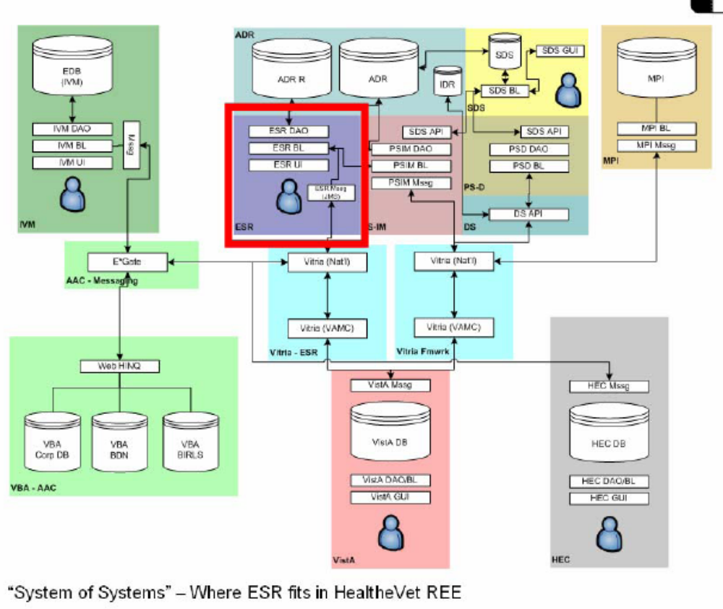
Figure 5: HECMS System of Systems
- VA Enrollment & Eligibility System
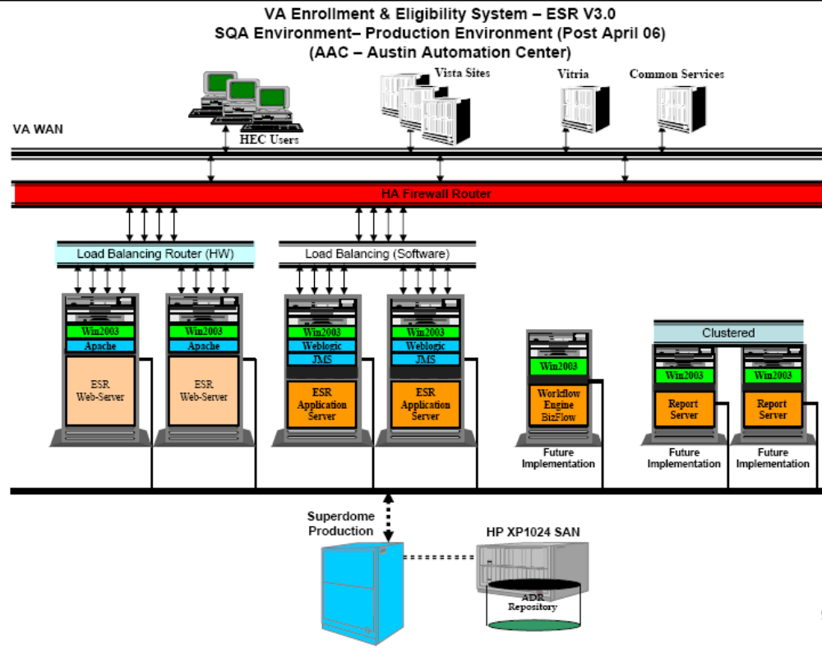
Figure 6: VA Enrollment & Eligibility System
- Person Services (PS) & Enrollment (HECMS)
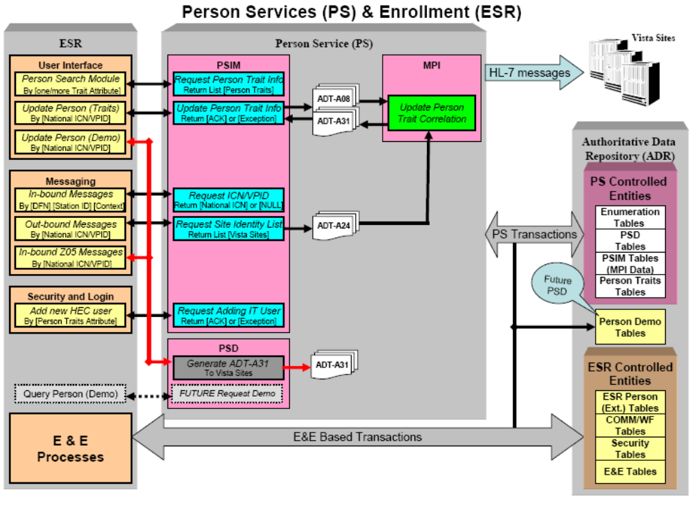
Figure 7: Person Services (PS) & Enrollment (HECMS)
Please note that in ESR 3.5, an additional web service interface was introduced between ESR and PSIM.
- Configuration Management Environment
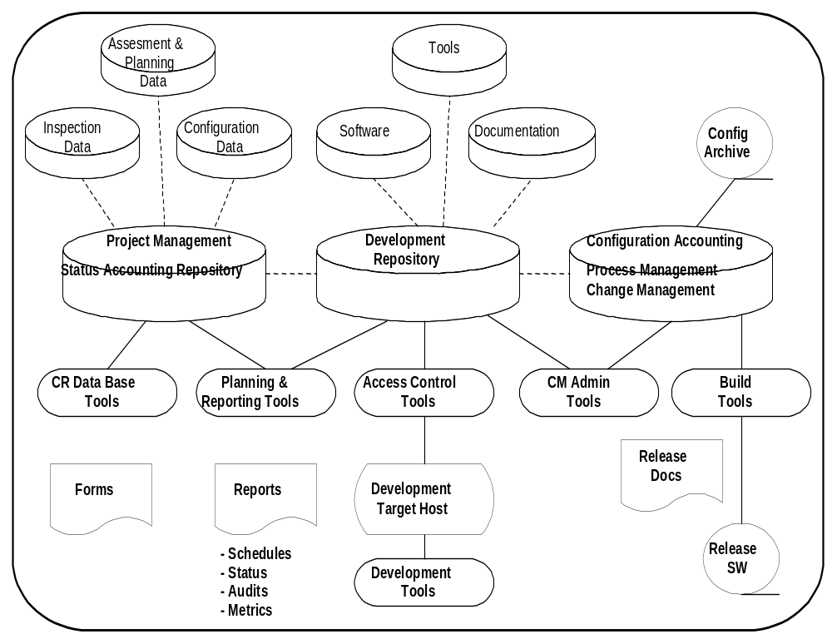
Figure 8: Configuration Management Environment
- ADR Definitions, Acronyms & Abbreviations
Acronym | Definition
ADR | (Administrative Data Repository) ADR is the national repository support that stores Administrative Data for the VHA legacy HEC system. ADR stores VistA File 200 Identity data as currently being enumerated by the Person Services Identity Management team.
ESR | (Enrollment System Redesign) A project effort designed for the completion development of the Enrollment Database (EDB) Version 3.0. EDB Version 3.0 replaced the HEC Legacy system and provides additional enhancements in support of the Health Eligibility Center.
CBO | (Chief Business Office) Directing body that represents the Federal/Congressional objectives of VHA and provides rulings, guidance and business requirements to Information Technology teams.
MVI | (Master Veteran Index) Master Veteran Index is an index that uniquely identifies each active patient treated by the Veterans Administration and identifies the sites where a patient is receiving care.
PSIM | (Person Service Identity Management) A portion of the common business services layers as prescribed by the HealtheVet logical model. Consists of a series of person oriented business components user interfaces for person identity management required to support implementation of service oriented n-tier application architecture. Centralized/distributed deployment architecture and application modernization as specified by VHA Enterprise Architecture.
PSD | (Person Services Demographics) A portion of the common business services layer as prescribed by the HealtheVet logical model. It will act as an authoritative source of patient administrative data and will formulate an abstraction layer between applications and databases. Comprised of a variety of sub-services, which support the input/retrieval of data and patient specific functionality such as lookup and enumeration.
HEC | (Health Eligibility Center) Central legacy repository for the veteran’s demographic, eligibility, enrollment, and financial data.
TSPR | (Technical Services Project Repository) Project repository for all HSD&D projects.
VA | (Department of Veterans Affairs) Department of Veterans Affairs (VA) was established on March 15, 1989, succeeding the Veterans Administration. Responsible for providing federal benefits to veterans and their families. Headed by the Secretary of Veterans Affairs, VA is the second largest of the 15 Cabinet departments and operates nationwide programs for health care, financial assistance and burial benefits.
VHA | (Veterans Health Administration) One of three major branches in the VA focuses on providing a comprehensive healthcare system for the nation's veterans.
VISTA | (VHA Information Systems and Technology Architecture) Automated information system that the Department of Veterans Affairs utilizes for the support of patient care at various medical facilities.
Table 15: ADR Definitions, Acronyms, & Abbreviations
- E&E Service Logical Architecture
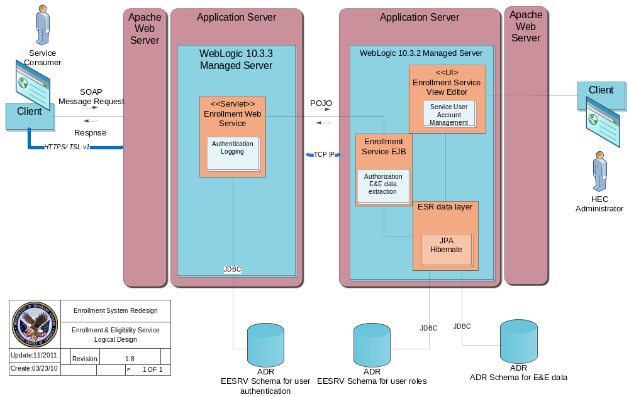Figure 9: E&E Service Logical Architecture
- E&E Service Logical Network Architecture
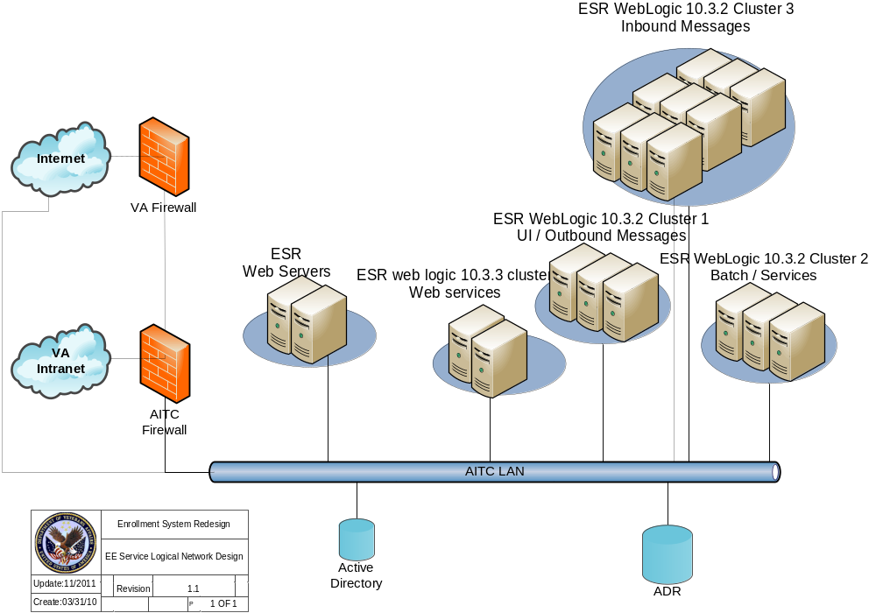Figure 10: E&E Service Logical Network Architecture

- E&E Service Software Components
- WebLogic 10.3.3
- JAVA 1.6.0
- Spring WS 2.0.0-M2
- Spring: 3.0.0
Glossary
Name | Definition
Apache Ant | A Java base application tool used to build software processes.
Apache Struts | A MVC framework used for the development of web based applications.
Architecture | The organizational structure of a system or component.
Configuration Control Board (CCB) | Represents a group of people who are responsible for evaluating and approving or disapproving proposed changes to a product and or project.
Hibernate | An Object Relational Mapping tool used to remove application components.
ILOG Rule | An execution engine that is responsible for application business management processes.
JasperReports | An open source components for J2EE based application. The solution provides out of the box capability for pdf and other template type reports.
JUnit | A unit testing framework used for testing the different components of an application.
Log4j | A lightweight utility framework that is used for logging, tracing and monitoring applications.
Spring Framework | A light container framework with an AOP base module support.
Table 16: Glossary of Terms

